Assignment 5 Report
Developing a Class-Based Ride Sharing System
Student Name
Course
Instructor
Date

Developing a Class-Based Ride Sharing System Using C++ and Smalltalk
Introduction
In this project, I created a Ride Sharing System using classes in both C++ and Smalltalk. The purpose was to exhibit the concepts of OOP such as encapsulation, inheritance, and polymorphism. There is a base Ride class along with two subclasses StandardRide and PremiumRide, and also two other classes Driver and Rider representing the ride sharing application which calculates fare, keeps track of rides, etc.
Encapsulation
Encapsulation was done by putting the data into the class and then accessing that data using the method and not letting the data be accessed directly. In the C++ code, attributes such as rideID, pickupLocation, dropoffLocation, distance and fare were kept private or protected inside the class and in the case of Driver class the attribute assignedRides was kept private and was modified by methods like addRide(). In the case of Smalltalk code, data was put into the objects as their state and accessed through message passing.
Inheritance
The use of inheritance was seen in the creation of two subclasses of the Ride class, namely the StandardRide and the PremiumRide. Both the subclasses used inheritance for inheriting their parent’s ride attributes and behavior while carrying out the calculation of fare in a unique way. Inheritance helped in reducing duplicate coding, as all common ride attributes had to be coded only once in the parent class. Inheritance was possible in both C++ and Smalltalk programming languages though the syntax differed in defining the subclasses.
Polymorphism
Polymorphism was shown in the overloading of the calculateFare() method in StandardRide and PremiumRide classes. Even though both the classes inherited from Ride, they calculated the fare in their own way. In the C++ program, there was a collection of Ride objects which were processed using base class pointers and thus, the overloaded function was called depending on the object at runtime. In Smalltalk, the same was done using dynamic message sending where the objects responded to the message according to their own version of the method.
Comparison of C++ and Smalltalk
Both languages facilitate object-oriented programming, albeit in different ways. In C++, type declarations have to be done explicitly, while in Smalltalk, object-oriented programs can be written without type declarations. C++ uses header files and source files, whereas Smalltalk uses an environment that allows classes and methods to be created interactively using the browser tool. Although C++ gives you more control of system resources and faster speed, Smalltalk gives a simpler environment to work on object-oriented programming ideas.
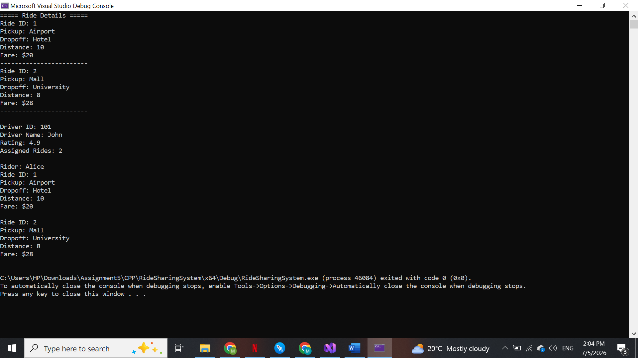
Conclusion
An example of the way object-oriented concepts can be employed in software design is shown by the Ride Sharing System. This program models the interaction between rides, drivers, and riders and exemplifies such concepts as encapsulation, inheritance, and polymorphism. Even though the two languages differ greatly, both Smalltalk and C++ offer good support for developing object-oriented software.
GitHub Repository
GitHub Link:
https://github.com/nadhikari48742/Assignment-5-Class-Based-Ride-Sharing-System

References
Object-Oriented Analysis and Design with Applications. (2007). Object-Oriented Analysis and Design with Applications (3rd ed.). Addison-Wesley.
Design Patterns: Elements of Reusable Object-Oriented Software. (1994). Design Patterns: Elements of Reusable Object-Oriented Software. Addison-Wesley.

